Livello 3: Go back to the starting location and then go to the throne room using only two commands

cd – **entriamo nella directory principale**

cd Castle/Main_building/Throne_room

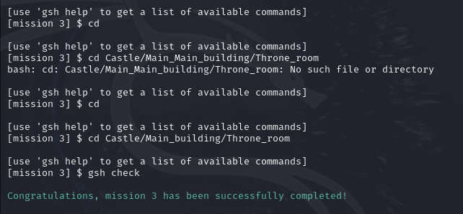

Livello 4: Build a "Hut" in the forest, and then build a "Chest" in the hut

cd -

cd Forest

mkdir Hut

cd Hut

mkdir Chest

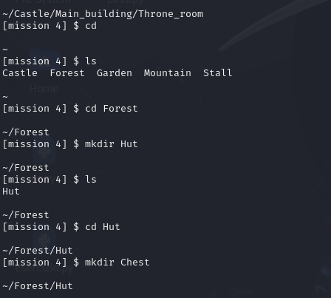

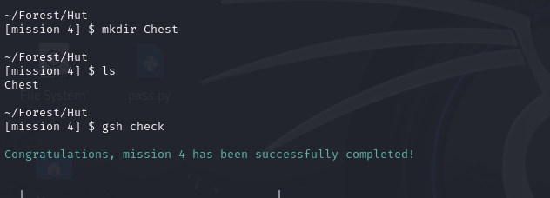

Livello 5: Go back to the cellar and get rid of all the spiders. Leave the bats alone: they appear on the castle's coat of arms and are said to confer luck.

cd -

cd Castle

cd Cellar

rm spider_1

rm spider_2

rm spider_3

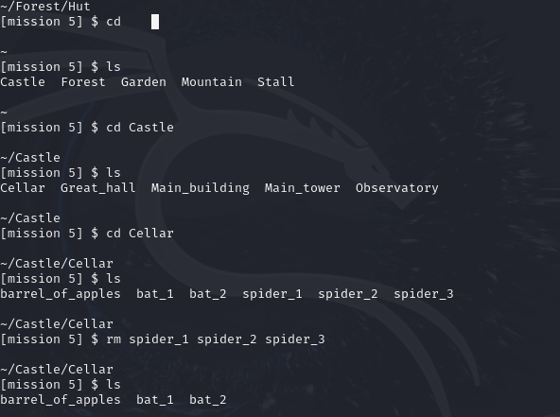

Livello 7: Collect all the coins hidden in the garden in front of the castle, and put them in your chest (in your hut in the forest).

ls -A

mv .21530_coin_3 ../Forest/Hut/Chest

mv .5095_coin_2 ../Forest/Hut/Chest

mv .60966_coin_1 ../Forest/Hut/Chest

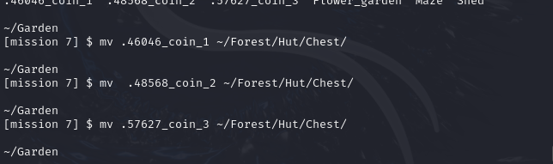

Livello 8: Get rid of all the spiders that are crawling in the cellar. Again, do not do not disturb the bats.

cd -

cd Castle/Cellar

rm *_spider_*



Livello 9: The spiders are getting clever: they found a way to hide. Get rid of all the spiders that are hiding in the cellar without disturbing the bats.

rm .*_spider_*

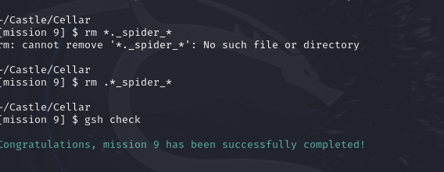

Livello 10: You have taken a fancy to the four standards in the great hall of the castle. As stealing them would not go unnoticed, put a copy (same name, same content) of each in your chest.

cd -

cd Castle/Great_hall

cp inserisco i diversi standard ~/Forest/Hut/Chest/

